I spent several weeks during spring 2019 studying from
"I, Pierre Rivière Having Slaughtered My Mother, My Sister And My Brother"
https://foucault.info/documents/foucault.pierreRiviere.foreword/

First because I knew René Allio from "Les camisards",
and I went to watch his film about that matter.
https://www.ina.fr/video/CPD92002667

Then I bought the collectiv book directed by Michel Foucault.
In french, I mean:
"Moi, Pierre Rivière, ayant égorgé ma mère, ma sœur et mon frère..."

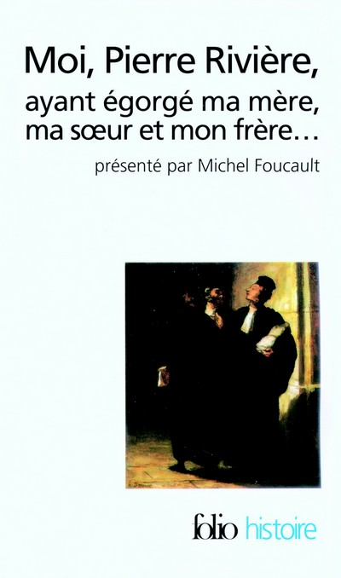

I made many studies by texts, sources, and 3D personnal videos and 3D personnal objetcs.

I had been also very excited to follow the trip Pierre Rivière did, after his murdering,
and before he had been arrested.
I did that with street view, from the map we could see in the book.

Links here:
http://mixed3d.net/artvrml/230317.htm
and here:
http://mixed3d.net/artvrml/300317.htm
and here:
http://mixed3d.net/artvrml/110517.htm
and here:
http://mixed3d.net/artvrml/180517.htm
and here:
http://mixed3d.net/artvrml/250517.htm
and here :
https://vimeo.com/362970114

all my study is here:
https://lartcommeonlaime.forumactif.org/t292-moi-pierre-riviere-ayant-egorge-ma-mere-ma-soeur-et-mon-frere

Here the 3 canvas sent :
http://mixed3d.net/foucault/foucaultdulenieu3canvasend.JPG

Alain Duménieu, 28 septembre 2019

